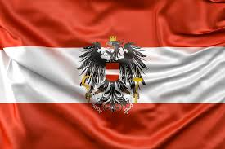
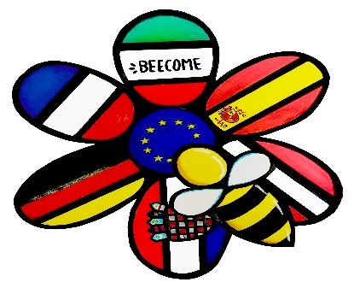
Train trip towards
Austria

In 2019, with the english workshop class, we went to Austria to present the « BEECOME » project (Bee in Europe an Example of Challenges Over Men and Environment), from Saturday 7 September to Saturday 14 September.

Saturday 7:
Departure from the college by bus at noon to Lyon station where we took a train to Switzerland, at Bern then to Austria overnight. It's been a long journey

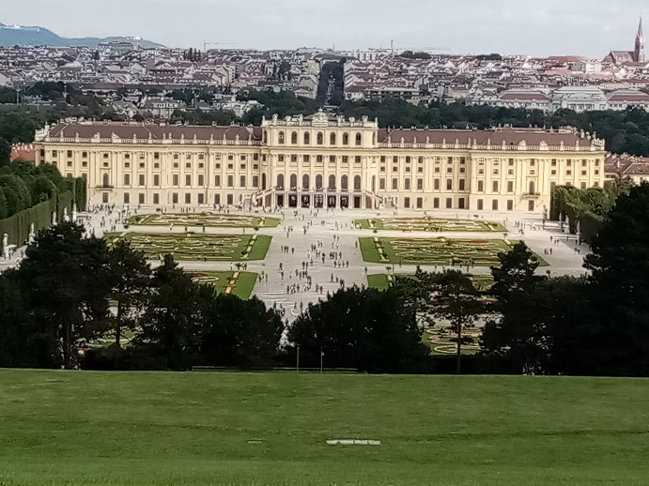

Sunday 8:
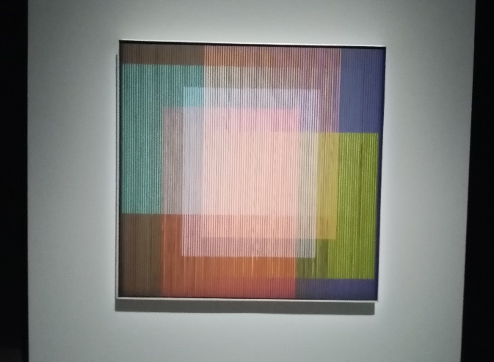
Once we arrived, we visited Schonbrunn Castle and its gardens. We then went to eat in a restaurant in downtown Vienna and then visited the Museum of Modern and Contemporary Art in Vienna, the Mumok. Finally we went to the boarding school where we met students from other countries and where we spent the night.

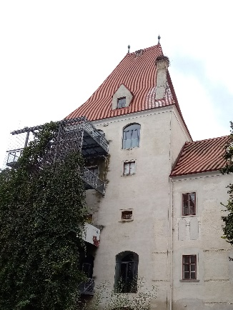

Monday 9:
We went to see the Danube National Park in Orth and its wildlife park where we saw the species present in the area. Then we went to meet a beekeeper and bee queen breeder, M.Bien, who made us taste his organic honeys.

Tuesday 10:
We presented our posters and photos in a high school room and we went to visit the city of Vienna with a guide who showed us every nook and cranny. Difficult to understand all the explanations in English.
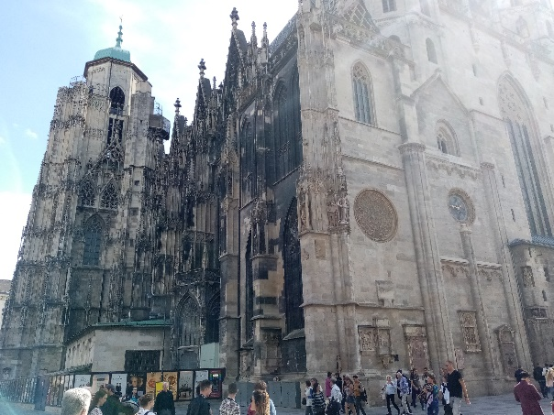
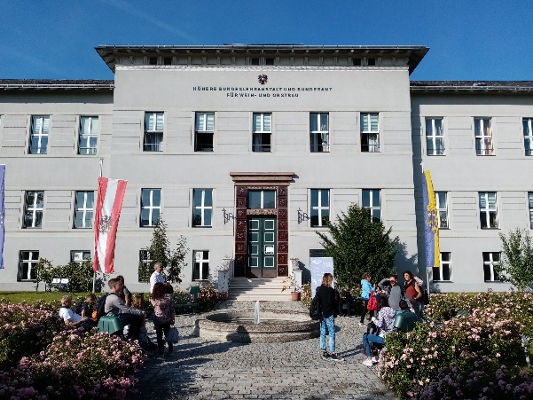

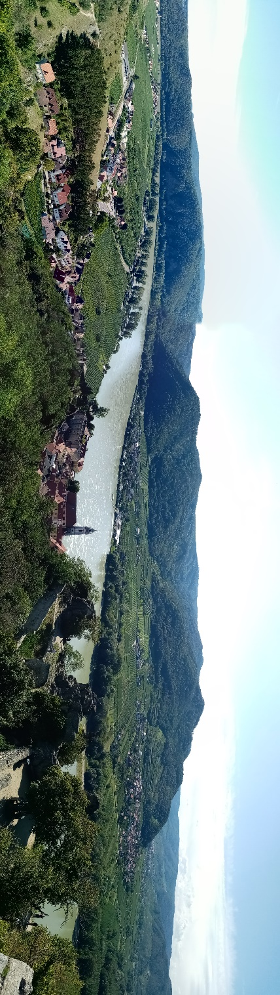
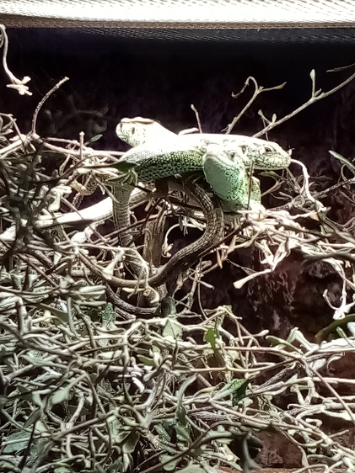
Mercredi 11:
We visited the Austrian Nature Museum and the Castle of Durstein along the Danube, then we were invited to eat at the winery of Mr. and Mrs. Jäger, we visited his Unesco World Heritage Sites vineyards.

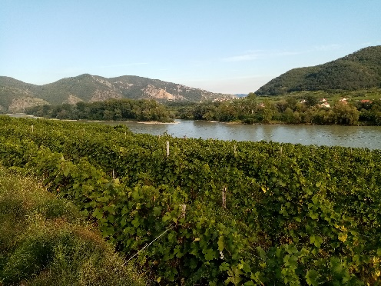

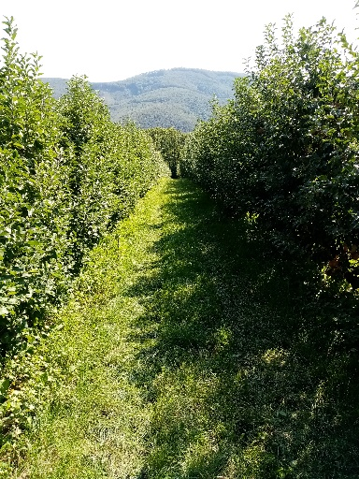
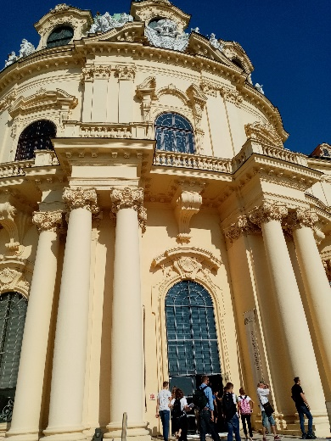
Jeudi 12:
On the last day in Austria, we visited the monastery of Klosterneuberg and then visited the green windows used by the high school which stretches over 18 hectares and we saw an experiment they were conducting on part of their apple tree to show the importance of pollinating insects. We tasted their apples and finished the day and trip with Olympiads and a barbecue.

